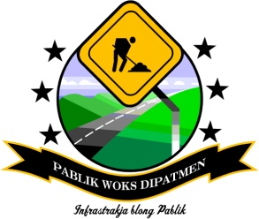

ENVIRONMENTAL MANAGEMENT PLAN

1. INTRODUCTION
The Contractor shall be responsible for following the Environmental Management Plan for the protection of the environment and mitigating impacts due to the work activities on the Site and follow the Vanuatu Environmental Management and Conservation Act (Cap 283).

This Environmental Management Plan defines the responsibilities of the contractor with regards to ensuring that the management of the of the road works is undertaken in professional manner that minimizes the environmental risks.

Contractor will:

- make this plan available to all workers on this project and ensure they have the opportunity to read, understand, clarify and ask questions;
- keep a copy of this plan readily available for the duration of the project;
- ensure that this plan is implemented in all relevant aspects.

2. ROAD CONSTRUCTION IMPACTS ON THE ENVIRONMENT
The environment is a very sensitive issue for both the contractor and the client. The actions of the road contractor in executing a contract can negatively impact the environment, and if measures are not taken to minimise or mitigate the impacts, it leads to environmental degradation.

During the implementation of road works, there are a number of temporary and permanent environmental impacts. Many of the impacts are a result of the used construction methods. Most of the negative impacts can be avoided or reduced by making provision for them during roadworks planning and design stage.
Examples of temporary negative impacts may include:

- Dust from haulage vehicles
- Sound pollution from heavy equipment
- Overexploitation of water sources by use for road construction
- Pollution of water sources from oil spills

Examples of permanent environmental impacts are:
- Loss of vegetation cover
- Damage to wetland resources
- Erosion
- Unrestored borrow pits
- Drainage into agricultural land
- Disruption of livelihoods of those settled along improved roads
- Increased run-off and changes in drainage patterns
- Changes in land use patterns and intensification of land use
- Changes in soil stability and erosion
- Impacts on domestic water supplies and wetland ecology
- Depletion of forests, flora, fauna and other natural resources
- Risk to protected areas such as forest and marine reserves
- Human population impact such as increased density, congestion, relocation, etc.

3. ENVIRONMENTAL PROTECTION MITIGATION MEASURES DURING ROAD WORKS
To ensure that we minimise these environmental impacts of road maintenance works, there needs to be environmental protection mitigation measures on the road works.

The Contractor is responsible for ensuring that protection mitigation measures as stipulated in the environmental laws and the contract are carried out and that the required quality of work is provided.

3.1 Clearing Vegetation
Avoid excessive clearing and removal of trees outside the roadway;
- Clear vegetation and removed trees only within the set horizontal alignment,
- Clear trees only marked and approved for removal,
- Do not clear food crops without the consent of the community,
- Do not burn cleared vegetation - transport to the borrow pits or designated areas.

3.2 Embankment Side Slopes
Protect embankment side slopes as unprotected steep slopes and gradients creates erosion after rains;
- Spread removed topsoil on all steep exposed formed slopes and embankments,
- Plant grass on exposed steep slopes and embankments within the roadway,
- Construct masonry (wet/dry), stone pitching, rip rapping in steep side drains, culvert inlet and outlet channels,
- Construct scour checks in steep side drains and susceptible drains to prevent erosion,
- Slope all vertical faces especially in catch water drains, mitre drains and culvert outlet channels

3.3 Waste Disposal
Avoid improper disposal of waste generated in the site camps;
- All waste generated in the camp should be disposed of in a dug out pits and covered when filled or during demobilisation,
- Provide pit latrines at the site camp, keep them clean and properly seal them when full or when the work is completed

Avoid improper disposal of replaced oils and lubricants from equipment maintenance;
- Dirty oil from equipment maintenance should be stored in drums for use in formwork,
- Ensure that equipment on site do not leak fuel (diesel/ petrol) and lubricants (engine oil, transmission oil, hydraulic oil),
- Repair all leaking equipment on site,
- Properly dispose of replaced parts like filters.

3.4 Water Pollution
Prevent the pollution of water bodies (streams and rivers);
- Ensure that latrines are sited far from water bodies,
- Do not dump left over concrete or wash concreting tools directly in water bodies,
- Avoid dumping of waste into water bodies,
- Overexploitation of water sources by use for road construction
- Pollution of water sources from oil spills

3.5 Air Pollution from Dust
During road works and its entire associated improvement works, the transportation of construction materials through villages by the haul vehicles leaves clouds of dust which can be hazardous to the health of the local population and for the environment.

Avoid dust, smoke and other forms of pollution;
- Minimise dust pollution by watering,
- Avoid burning in all forms of rubbish on the site.
Mitigation as follows:
- If available in the close proximity of the site (up to 1 km), the route should be sprinkled with water thrice a day (in the morning, midday and 3 o'clock). The sprinkling should be light in order not to lead to flooding of the road, which can lead to slipping off the road by various forms of traffic.
- Humps should be erected on the access routes to serve as speed regulators in order to reduce dust production.
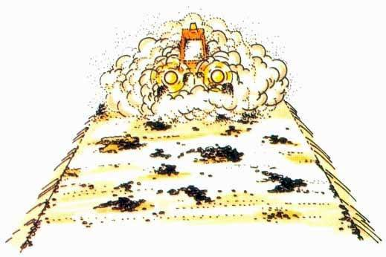
Figure 4: Avoid dust problems

3.6 Disturbance to Protected Areas (Forest Reserves)
When the works occur in protected area and forest reserves impacts on wildlife and forested areas in terms of destroying wildlife and encroachment to ecosystems must be avoided. Related problems include:
- Road workers on roads that pass through protected areas must not be allowed to trap wild animals especially the birds and fish in marine protected areas. They also must not exploit forest resources at the expense of the protected area.
- Workers may not harvest firewood and other forest resources from the forest protected areas.
- Prevent the disruption of wildlife and forest ecosystems along the road especially in the process of working within the road reserves of protected areas.
- Workers should be reminded not to enter the protected areas beyond the road reserve.

3.7 Road Accident Risks
Road accident risks are a potential danger during road works and its subsequent usage. During road works, the road repaired is open to traffic and a host of other road users. To prevent accidents occurring on roads under repair:
- The area/section of the road under repair should be clearly marked off with either flagging tapes or red-white cones (reflective)
- Road workers should be briefed regularly of the dangers related to roadworks open to traffic
- The section being open to traffic should be clear off all road equipment and construction materials (such as coral piles)

3.8 Borrow pits / Quarries
In order to restore the borrow site, the following actions are to be undertaken:
- First, collect all the vegetation matter on the site (grass, shrubs and possibly tree materials). This should be stockpiled aside near the pit.
- The topsoil should be collected on a separate site in the vicinity of the borrow pit/quarry. Topsoil should be used for the reinstatement of the site, in a way that it is spread equally over the area as a final top layer
- Different layers of soil should be stockpiled separately once excavated.

After extracting gravel, the area should be restored as follows:
- All unused/oversized gravel boulders should be placed back in pit as the first layer of material in the base of the pit.
- The subsoil material should then be placed back and evenly spread over the boulder materials.
- The top soil is eventually returned and spread over.
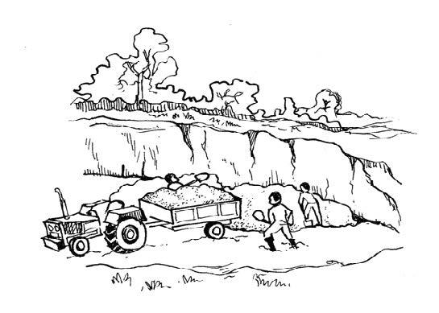
Figure 1: Quarry Operations
- The sides of the pit are levelled giving a gentle slope (eliminating the sharp cliffs).
- Levelling should ensure surface water run-off, water collection in the pits should drain naturally in order to reduce incidence of disease vectors.
- In order to enhance regeneration of vegetation, sods (stems) of grass for instance, can be planted on the site.
- Depending on the landowner, it is advisable to plant some trees on the site especially, when the site is extensive to facilitate the area to blend well with the adjacent areas. Preference could be for indigenous trees, which do not require serious farming and are locally available.

3.9 Camp Sites
The Contractors should always reinstate the campsites to its original condition, During the reinstatement and demobilization phase, Contractor shall comply with the following requirements:
- Relocate machinery and all the parts and accessories used;
- Identify competent persons to manage any demolition process;
- Establish sites where the materials can be safely deposited;
- Safely deposit the material at the selected sites and, whenever possible, reinstate the sites to their original condition;
- Cover Latrine pits and dispose of hazoudous and non-hazdous wastes in the proper location as per the Vanuatu Environmental Management and Conservation Act (Cap 283) .

