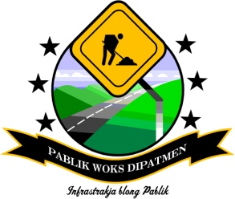

TRAFFIC MANAGEMENT PLAN

1. INTRODUCTION
This Traffic Management Plan defines the responsibilities of the contractor with regards to ensuring that the management of the traffic during the period of the execution of road works is undertaken in professional manner that minimizes the risks related to the safety of workers, road users and general public.

Contractor will:

- make this plan available to all workers on this project and ensure they have the opportunity to read, understand, clarify and ask questions;
- keep a copy of this plan readily available for the duration of the project;
- ensure that this plan is implemented in all relevant aspects.

The Contractor shall be responsible for providing the safe passage of traffic through the work site and keeping the site open to traffic at all times.

This requires the contractor to procure/produce traffic warning signs and using them to control vehicles to keep the section on which the contractor is working safe for the workers and road users.
- The Contractor will provide the estimated the number and type of traffic warning signs and type of safety equipment that could be produced locally according to design and specification;
- Keep existing roads that are undergoing maintenance improvements open and maintained in such a condition as to safely accommodate traffic;
- Provide and maintain temporary detours, approaches, or crossings and intersections with trails, roads, businesses, parking lots, and campgrounds in a safe and passable condition;
- Existing access levels will be maintained through the provision of temporary crossing as required at each site;
- Vehicular access to adjacent properties shall be maintained throughout construction except for essential works where temporary closure shall not exceed one hour per day;
- Where access is temporarily affected, the Contractor shall notify the affected parties of the disruption at least 7 days prior;
- Excavated areas are to be clearly marked to protect people, especially children, from harm;
- Traffic control measures shall include reducing the speed limits through construction sites and adjacent villages.

2. Roadworks Safety Signage and Safe Traffic Control

Where work is being done on roads, proper safety mechanisms should be in place to reduce accidents, by:

- Erecting temporary signs, and;
- Establishing temporary traffic control measures.

This will indicate to the drivers that work is in progress along sections of the roads ensure smooth and safe traffic flow.

2.1 Installation of Traffic Signs

Temporary traffic signs must be used to direct traffic to safely manoeuvre their way through or around a road maintenance zone. Before work starts and during the works, informative and warning signs and barriers must be placed around the work area.
The following conditions are satisfied when fixing and positioning temporary traffic signs:
- They are clearly visible and provide sufficient reaction time.
- Those signs that must remain in place throughout the maintenance period and must be securely fixed to prevent them being removed by passers-by.
- The temporary signs must at all times be positioned at relevant locations, and be moved accordingly as the work progresses. This means the temporary signs must be removed promptly once the works for which they were erected are finished.
- Signs shall be reflectorized and kept clean and readable at all times

2.2 Traffic Control and Safety

The contractor must ensure that:

- The necessary temporary traffic signs and protection are provided and correctly located on site for the duration of the work;
- All equipment and vehicles are parked off the carriageway or behind protective barriers and signs, when not in use;
- No material is to be left in a dangerous location and that the road adjacent to the work site is kept clean and swept of any debris arising from the work;
- All excavations are protected for the benefit of all road users, equipment and workers;
- All operators are trained in the operation of their equipment;
- Operators and labourers are informed of the potential risks of and procedures for working with or close to machinery;
- Traffic control operations are carried out properly and that road users are not unnecessarily delayed;
- Where work on the carriageway or shoulder remains unfinished overnight, then proper warning lights are to be arranged and, protected;
- All sites are to be left tidy and cleared of debris when the work is completed.

- There are temporary warning signs at both ends of the maintenance site to advise road users that works are in progress and to reduce vehicle speed. Two signs of “Workers Ahead” signs (or Yellow/ Orange flags) placed on the traffic side road edge 200 m before and after the site where work is in progress;
- Warning signs for narrowing ahead placed 100 m before where the work is in progress.

Wherever possible, diversions should be established so that traffic can be directed away from the road section under work. Properly installed road signs, which clearly show the diversion, are essential and the road or road section under work needs to be blocked by adequate barriers and signals.

All traffic signs must be installed before commencement of work activities and removed immediately upon the completion of works.

After the diversion has been completed and before work starts, warning signs, barriers and cones must be placed around the work area. Signs must be placed in the order s shown on Figure 13, in the Appendix 1.

Appendix 1: Traffic Signs
Figure 1: Men Working | 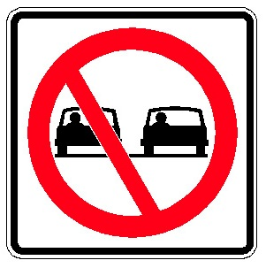  Figure 2: No Passing | 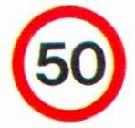  Figure 3: Speed Limit Sign
Figure 4: Stop Sign | 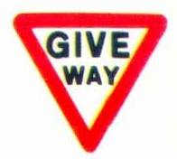  Figure 5: Give Way Sign | Figure 6: End Local Speed Limit
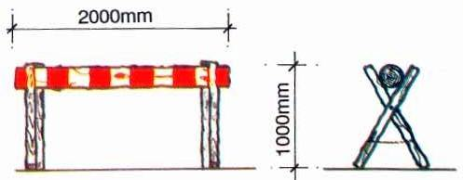  Figure 7: Traffic Barrier |  | 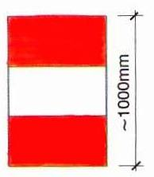  Figure 8: Traffic Barrel
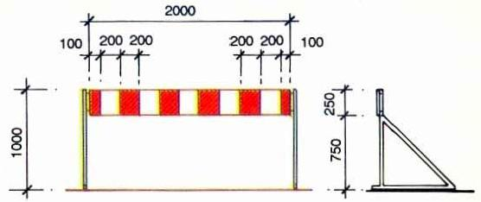  Figure 9: Traffic Lane Close |  | 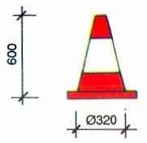  Figure 10: Traffic Cone
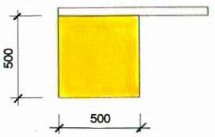  Figure 11: Warning Flag | 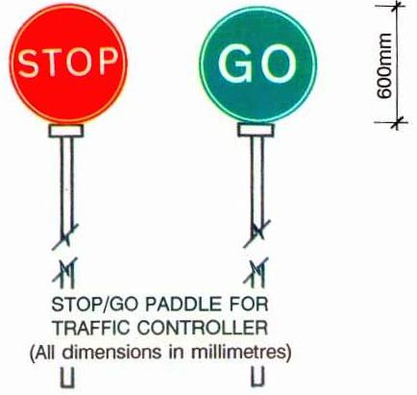  Figure 12: Stop Go Paddle

- Workers ahead signs should be placed 200 metres in front of the work area.  - Turn Left/Right¨ arrows should be placed 100 metres in front of the work area.  - Cones should be placed diagonally across the road to lead into the diversion.  - Keep Left/Right¨ arrows should be placed at the ends of the lines of cones.  - Barriers should be placed behind the lines of cones.  - End of Restriction¨ signs should be placed beyond the ends of the diversion.  - At night yellow lamps should also be used to mark the extent of the work at the diversions. | 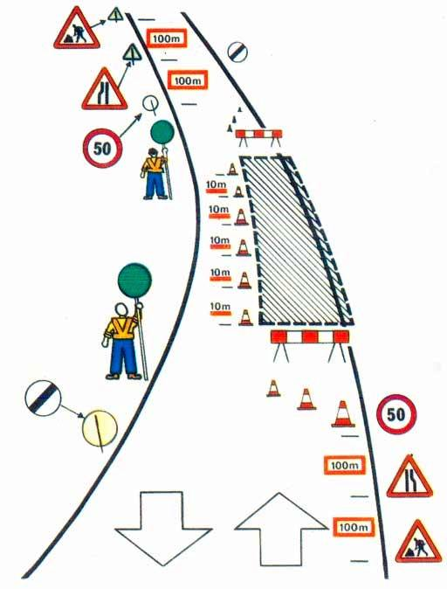  Figure 13: Typical signing at work site

